**Architecture**

To paint a clearer picture of how this can work, here is a diagram of the architecture we will be working with. If you have suggestions or ideas, please take note so we can go over it in our first meeting which is still to be determined. For instance, there are numerous ways to handle queries through servlets using ajax or JQuery.

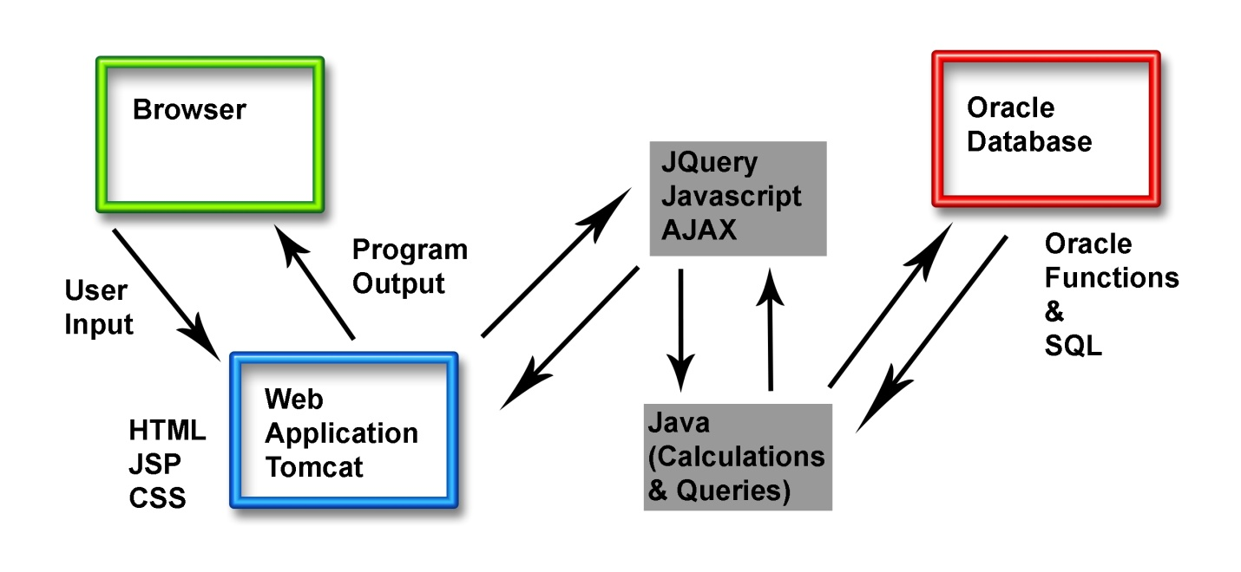

Keep in mind this is more of a guideline. Sometimes you are forced to use java code inside a JSP, but its best to keep it separate. This diagram is to help us decide where we will be putting our individual focuses and how to keep the division of programming languages. However, we are not limited to any one area and I will do my best to help others out in other areas in the event we are falling behind or help is needed.

**Application Design**

Since everyone was ok with either of the suggestions made, I decided to go with the first suggestion, the mortgage loan pricing program. The main reason is because we can do a lot more with it if we have time, the calculations involved are challenging, but not impossible and I think it allows us to divide the project into approximately five portions relatively easily. The complexity won’t be overwhelming so we can all have a chance to grasp how each portion works in the entire scheme of the program.

To start the database will need the base attributes that we will work off of. Below is draft of the tables and attributes that will be used.

|  |  |  |  |  |  |  |  |  |
| --- | --- | --- | --- | --- | --- | --- | --- | --- |
| Tables | Attributes | | | | | | | |
| Lender | Lender_ID | Name | Address_ID | Loan_ID | Home_ID | Phone | Email |  |
| Clients | Client_ID | Name | Address_ID | Loan_ID | Home_ID | Credit_Score | Phone | Email |
| Loans | Loan_ID | Term | Type | Rate |  |  |  |  |
| Home | Home_ID | Type |  |  |  |  |  |  |
| Address | Address_ID | Street | City | State | Zip_Code |  |  |  |

I tried to normalize it the best I could, but like I said this is only a draft. What I wanted to display is how we will handle our calculations. How it works is each lender has a base rate that they start their pricing. The home type (single family, condo, etc.), term, loan type (fixed or adjustable), credit score, and many other factors that I have not included yet will either be an increase or decrease onto the rate. Essentially, we will query the database for the information submitted by the user and we will determine the rate within the code. Once we have the rate we can determine the payment with the loan term and type. This scratches the surface of what the program can be designed to do. I think this is how we should start. Along with this word document I am also including two Excel spreadsheets I had written a few years ago for my clients when I worked as a loan officer. I will also include a rate sheet used for pricing to help you grasp what I mean. These will be helpful in deciding what we can incorporate into our program.

I think this is a good start to build off of. I sent out a private message encouraging everyone to swap Skype handles, but I think many of you have beaten me to it. I think everyone has been anxious to start which is great! I look forward to working with you all.

Kindly,

Pierro